**CENWP-OD-B 19 August 2024**

**MEMORANDUM FOR THE RECORD**

**SUBJECT: 24BON046 MFR AFF Valve 15 Chinook Salmon Mortality**

On the morning of 19 August 2024, CRITFC Biologists notified Project Biologists of one adult Chinook salmon mortality discovered on the Adult Fish Facility’s valve 15 trash rack. The fish was measured, scanned for PIT tags, inspected, and returned to the river.

1. Species – Chinook Salmon (*Oncorhynchus tshawytscha*)
2. Origin – Unknown
3. Length – approximately 85 cm fork length
4. Marks and tags – Clipped adipose fin
5. Marks and Injuries found on carcass – Bleeding from vent and decomposing.
6. Cause and Time of Death – Unknown
7. Future and Preventative Measures – N/A

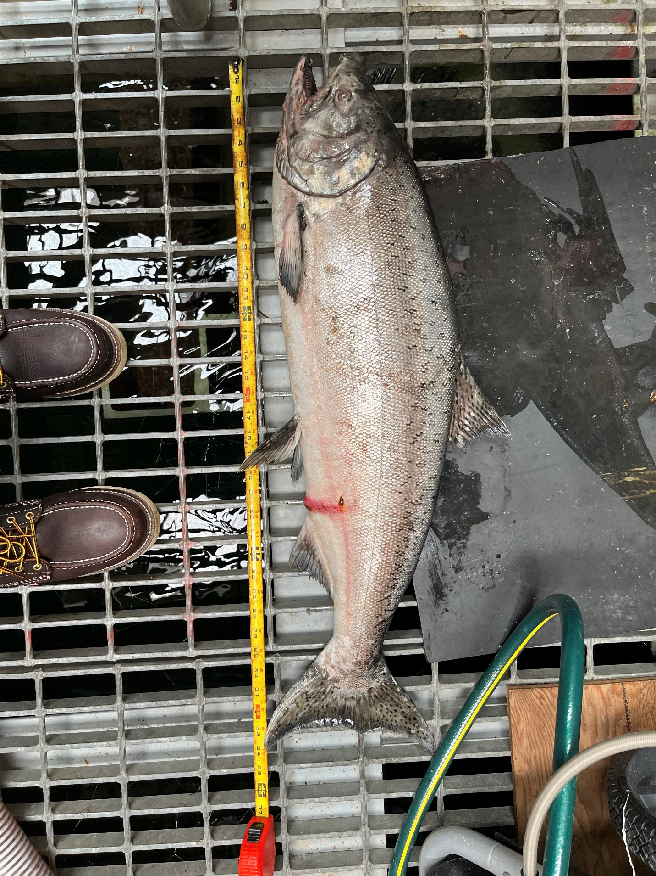

Sincerely,

Bonneville Project Fisheries